***Microservices Documentation***

**Step1:**

**Launch 2 EC2 instances:**

Instance 1: wordpress

AMI: Ubuntu (latest version)

Instance Type: t2.micro

Key Pair: Create key pair (for SSH access)

Security Group: HTTP, HTTPS, SSH, MYSQL(Only from the MySQL instance private IP),TCP

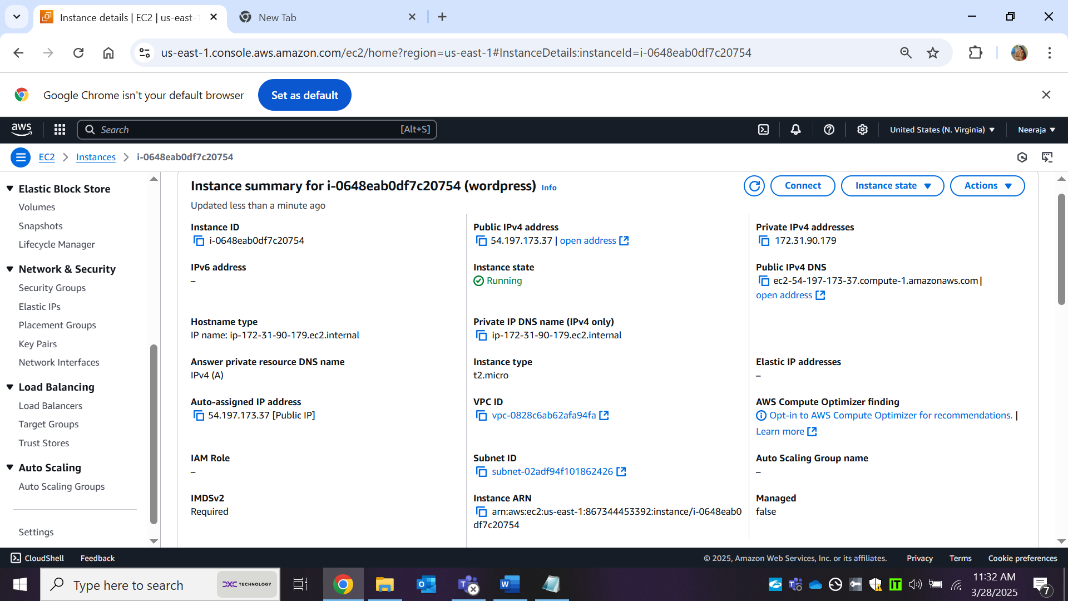

**STEP2:**

Instance 2:

Name: mysql

Instance Type: t2.micro

Security Group: Separate security group for MySQL(Allow inbound from WordPress Private IP)

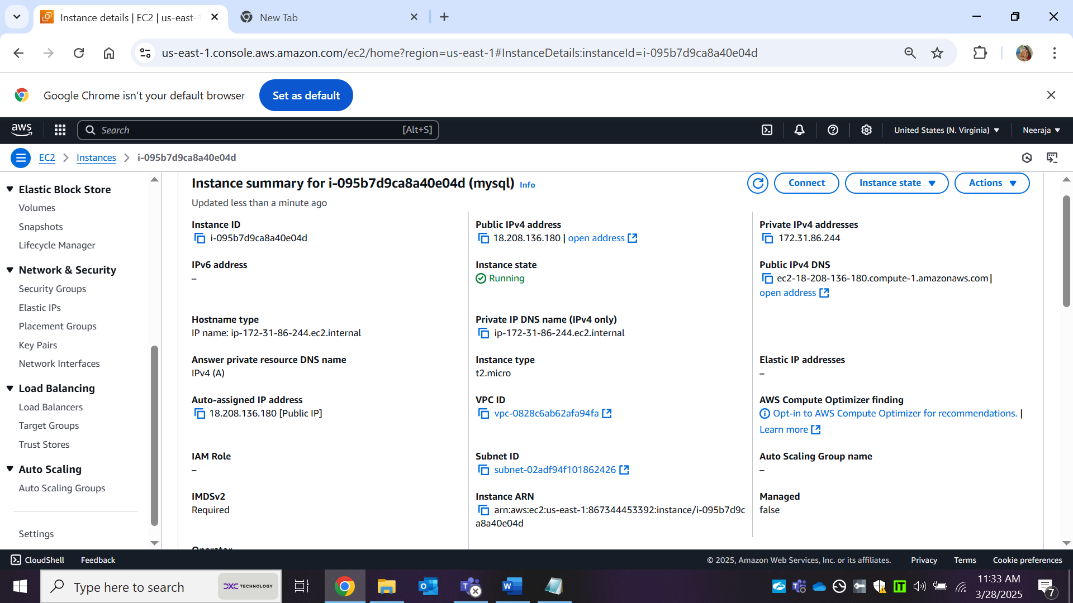

**Step 3: Install and Configure MySQL on MySQL Instance:**

3.1: Connect to MySQL EC2 Instance:

ssh -i your-key.pem ubuntu@your-mysql-instance-public-ip

3.2: Install MySQL Server:

sudo apt update

sudo apt install mysql-server -y

3.3. Secure MySQL Installation

sudo mysql_secure_installation

* Set root password

* Remove anonymous users

*Disable remote root login

*Remove test database

3.4. Create WordPress Database & User

sudo mysql -u root -p

Inside MySQL shell, run:

CREATE DATABASE wordpress_db;

CREATE USER 'wp_user'@'%' IDENTIFIED BY 'yourpassword';

GRANT ALL PRIVILEGES ON wordpress_db.* TO 'wp_user'@'%';

FLUSH PRIVILEGES;

EXIT;

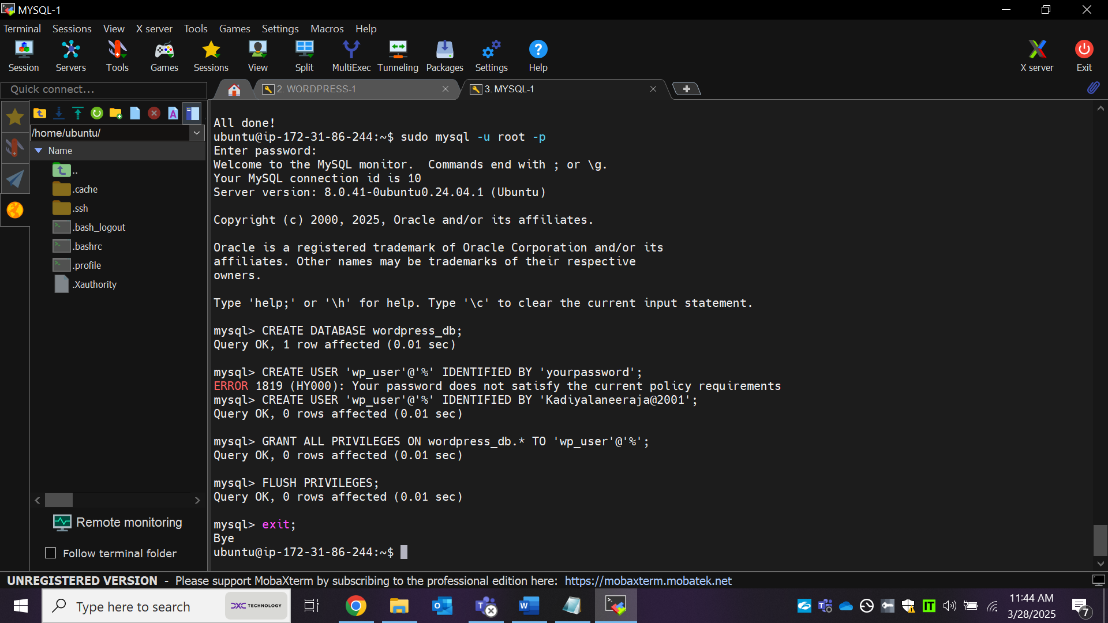

**3.5. Allow Remote Connections: (Edit the MySQL config:)**

sudo nano /etc/mysql/mysql.conf.d/mysqld.cnf

Find the line:

bind-address = 127.0.0.1

Change to: bind-address = 0.0.0.0

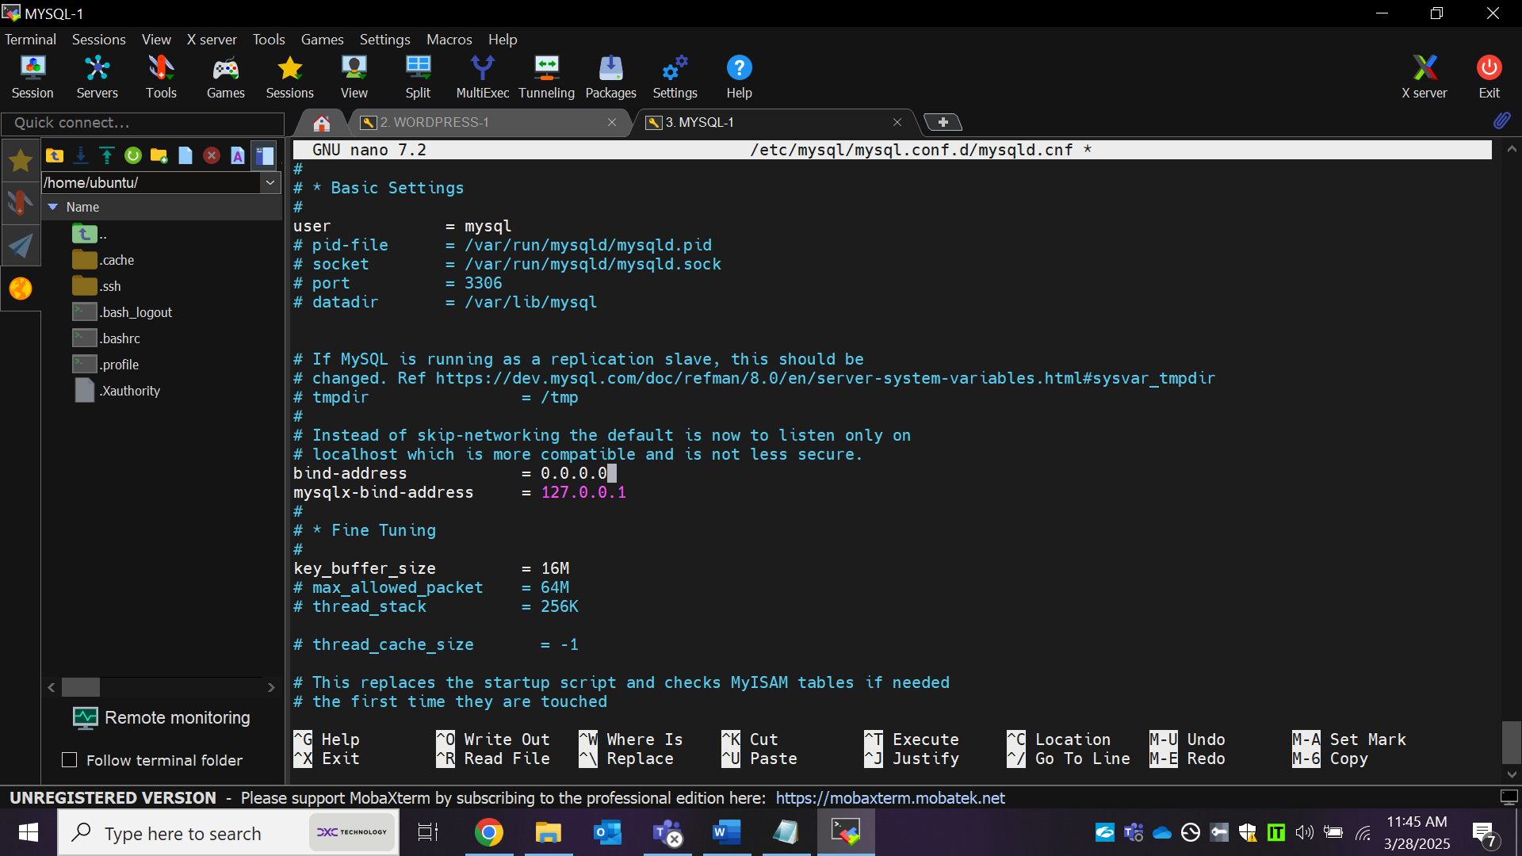

**Restart MySQL:**

sudo systemctl restart mysql

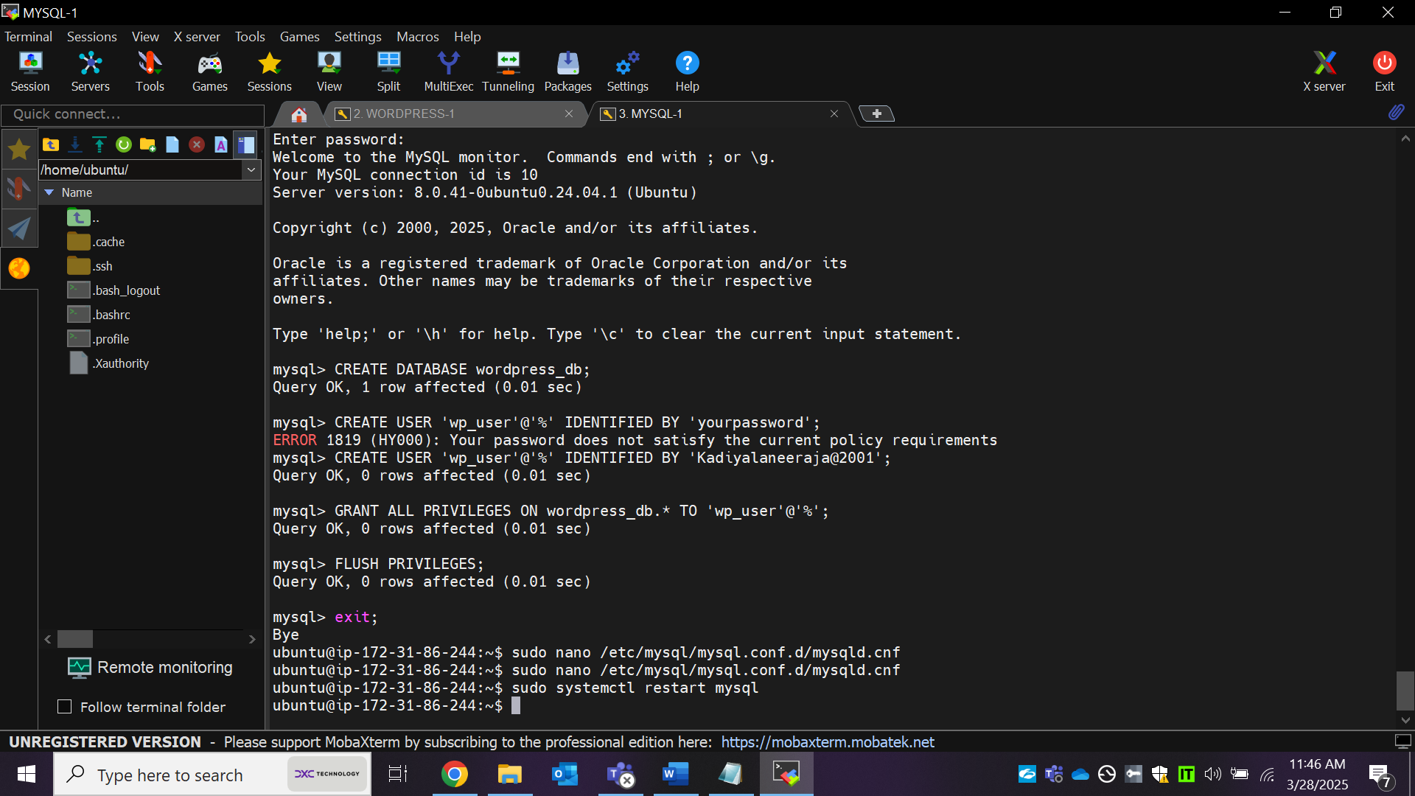

**Step 4: Install and Configure WordPress on WordPress Instance:**

4.1. Connect to WordPress EC2 Instance

ssh -i your-key.pem ubuntu@your-wordpress-instance-public-ip

4.2. Install Apache, PHP, and Dependencies

sudo apt update

sudo apt install apache2 php php-mysql libapache2-mod-php unzip -y

4.3. Download and Extract WordPress

cd /var/www/html

sudo wget https://wordpress.org/latest.zip

sudo unzip latest.zip

sudo mv wordpress/* .

sudo rm -rf wordpress latest.zip

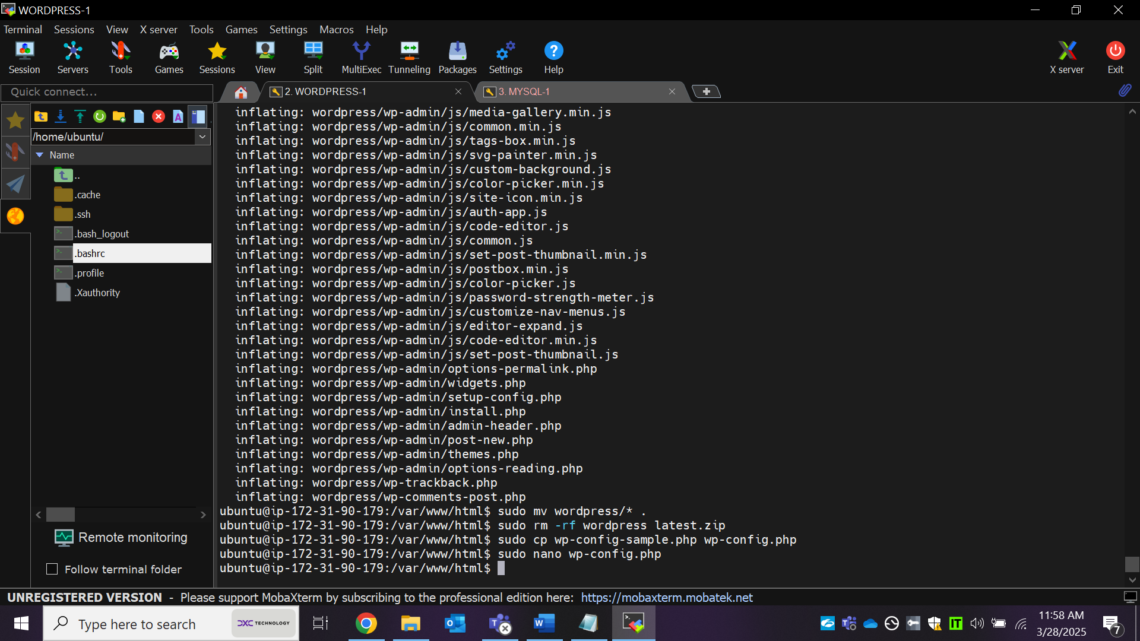

4.4. Configure WordPress Database Connection:

sudo cp wp-config-sample.php wp-config.php

sudo nano wp-config.php

Modify these lines with your database info:

define('DB_NAME', 'wordpress_db');

define('DB_USER', 'wp_user');

define('DB_PASSWORD', 'yourpassword');

define('DB_HOST', 'your-mysql-instance-private-ip');

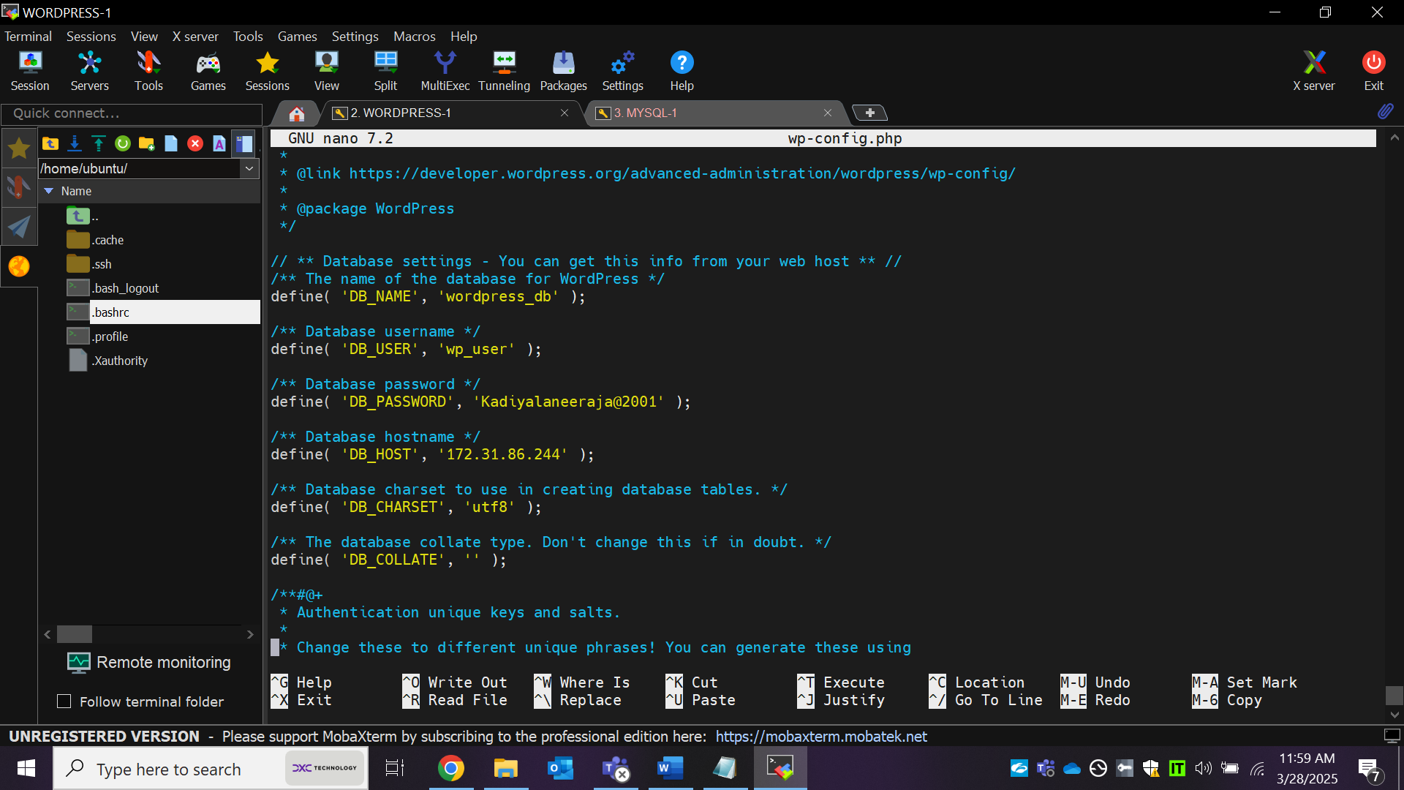

4.5. Set Permissions:

sudo chown -R www-data:www-data /var/www/html

sudo chmod -R 755 /var/www/html

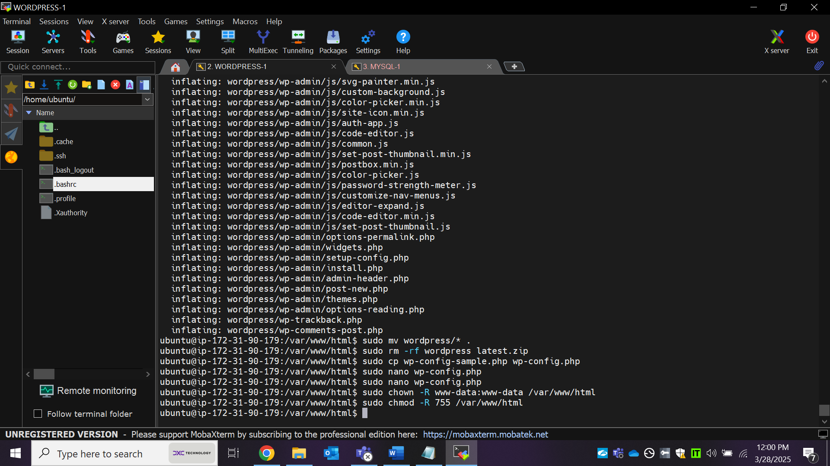

4.6. Restart Apache:

sudo systemctl restart apache2

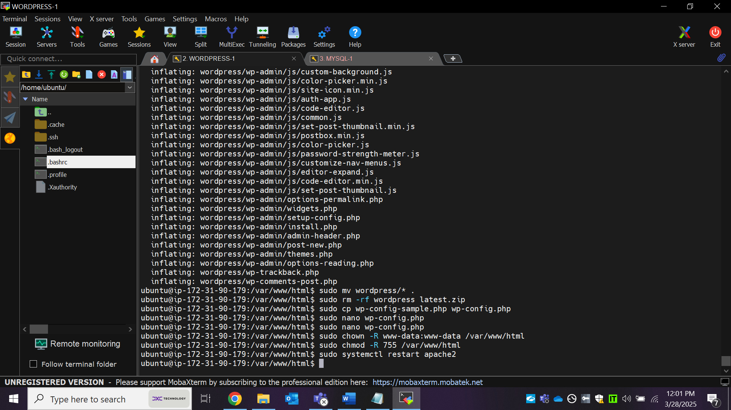

Step 5: Access WordPress & Create Welcome Page

1. <http://your-wordpress-instance-public-ip>

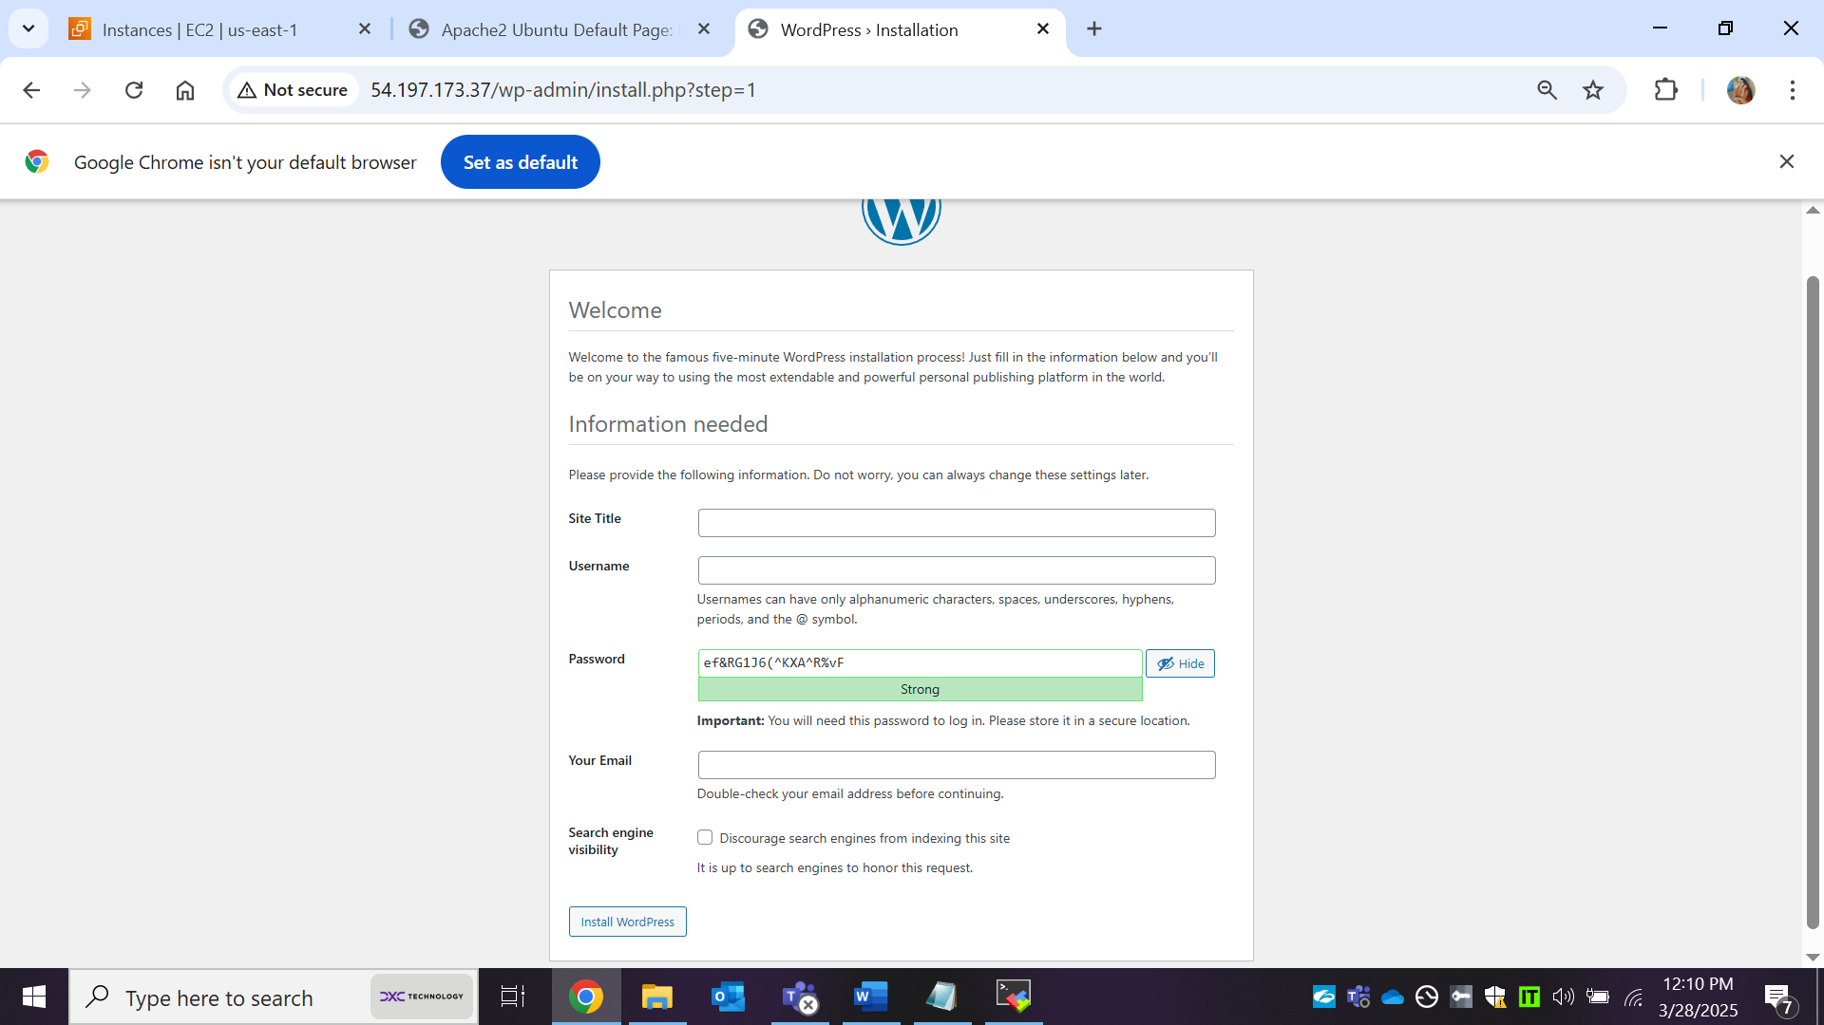

1. Complete WordPress installation:

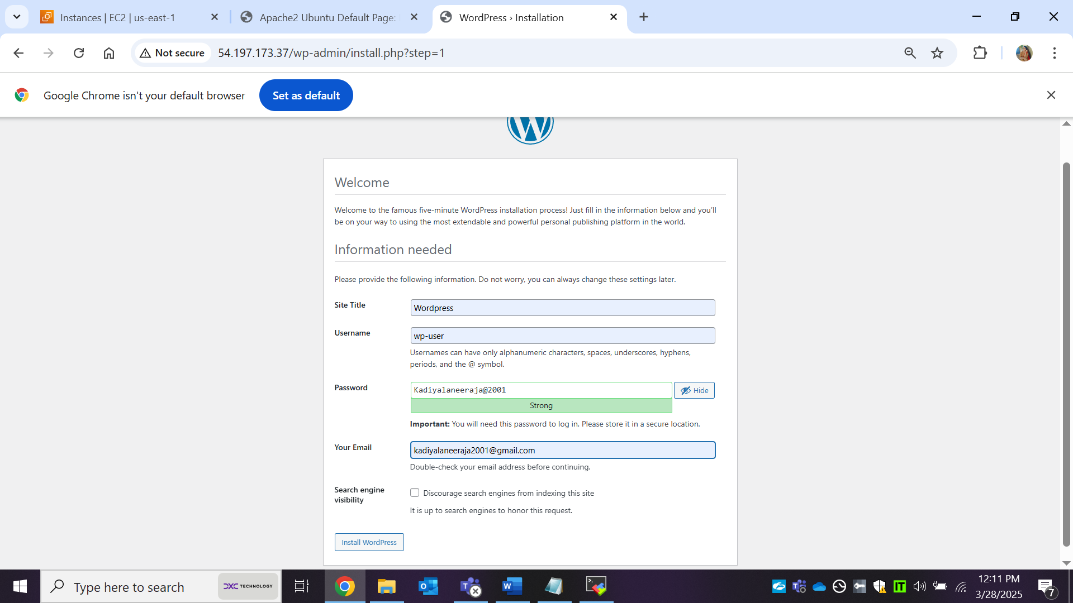

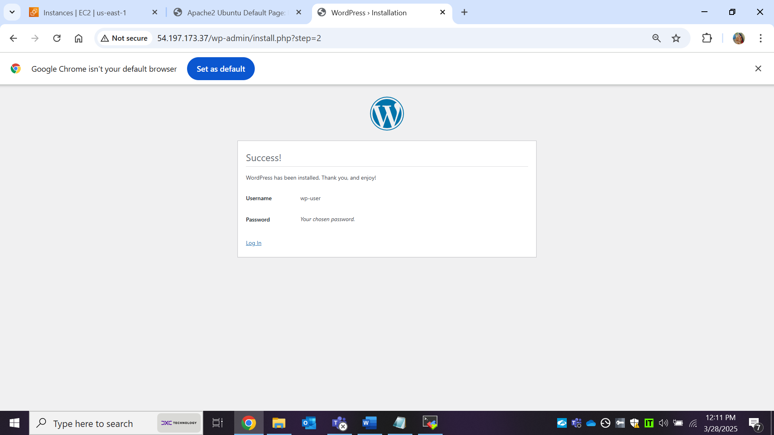

log into Wordpress page:

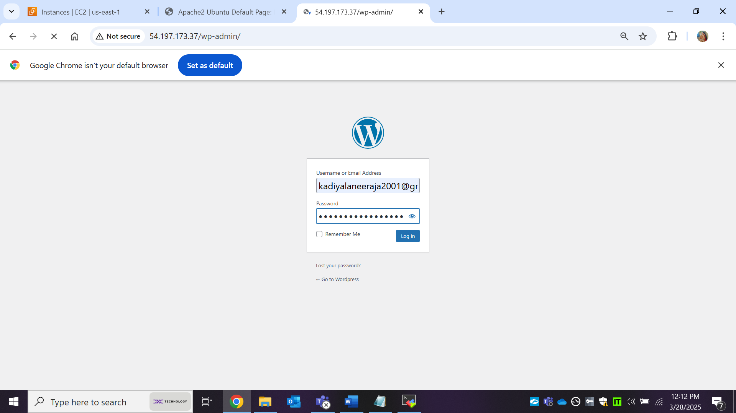

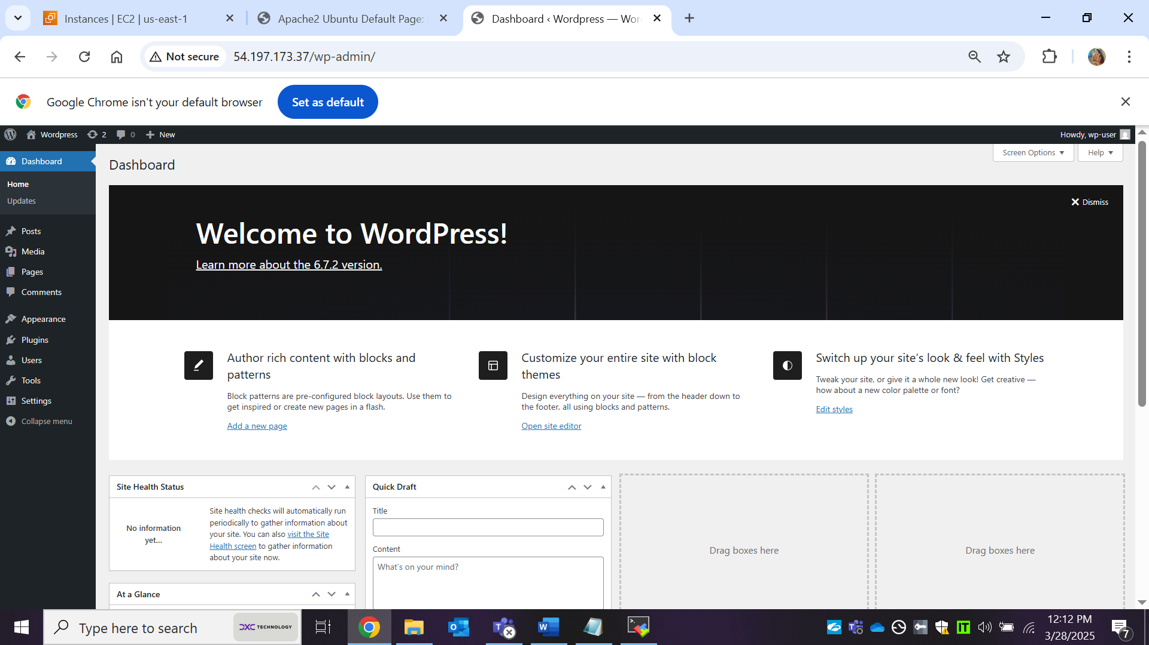

Add a New Page & add your own content:

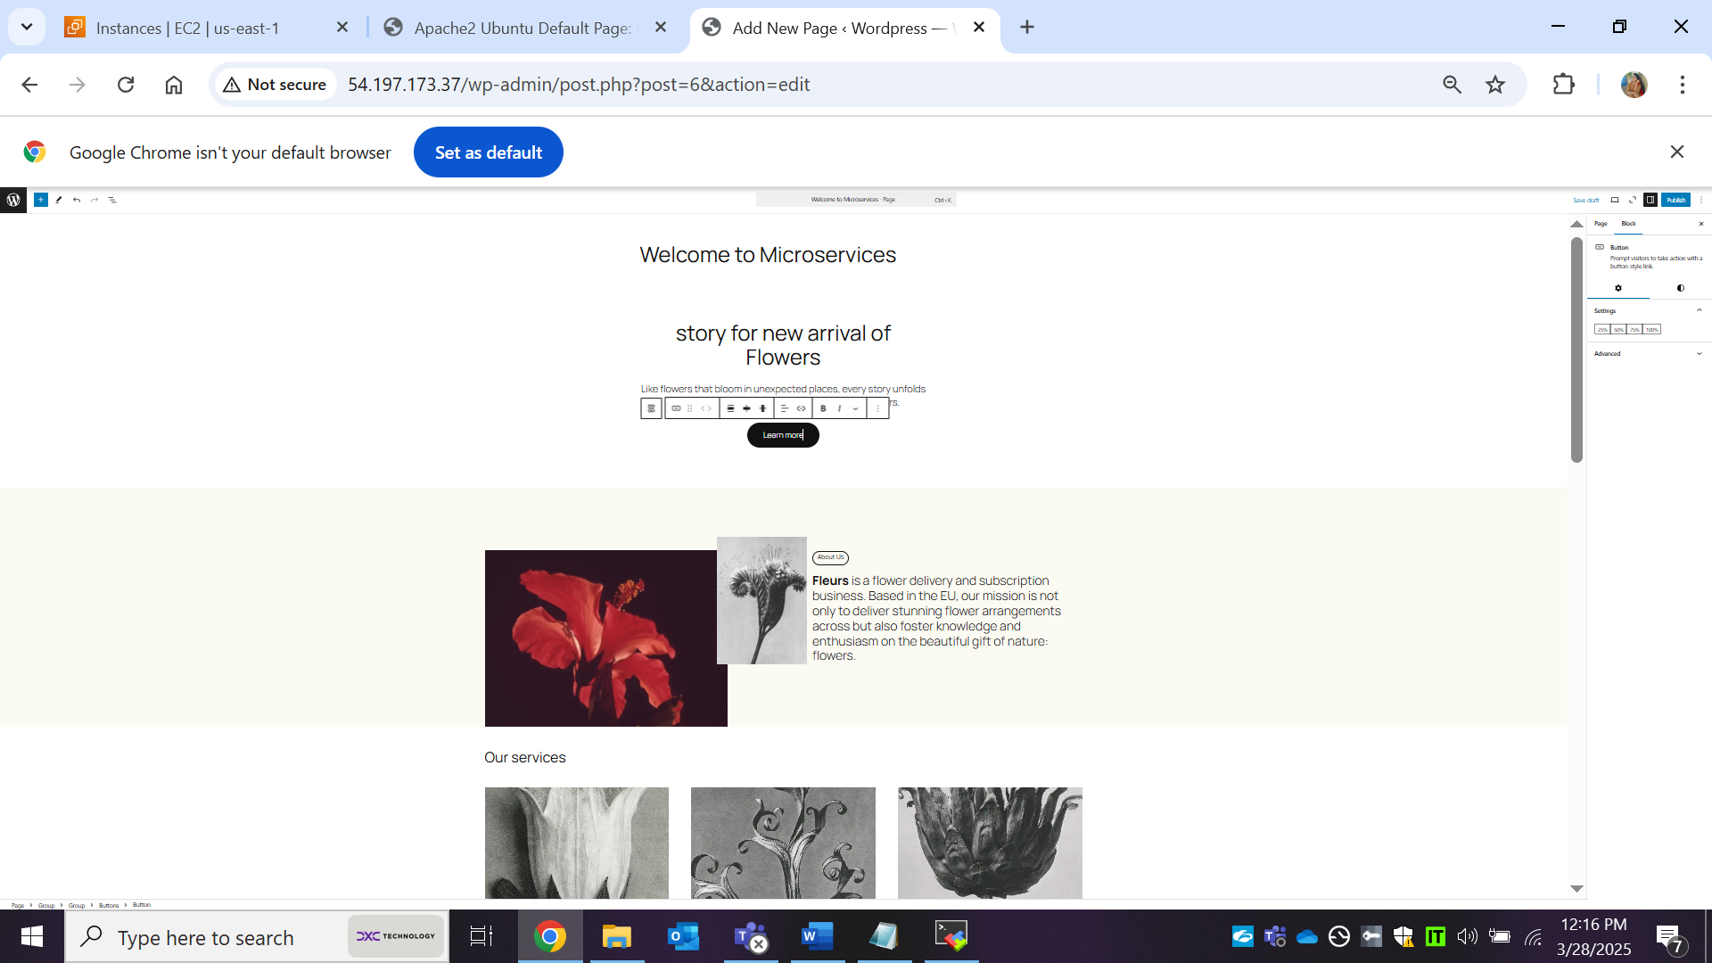

After publish your content:

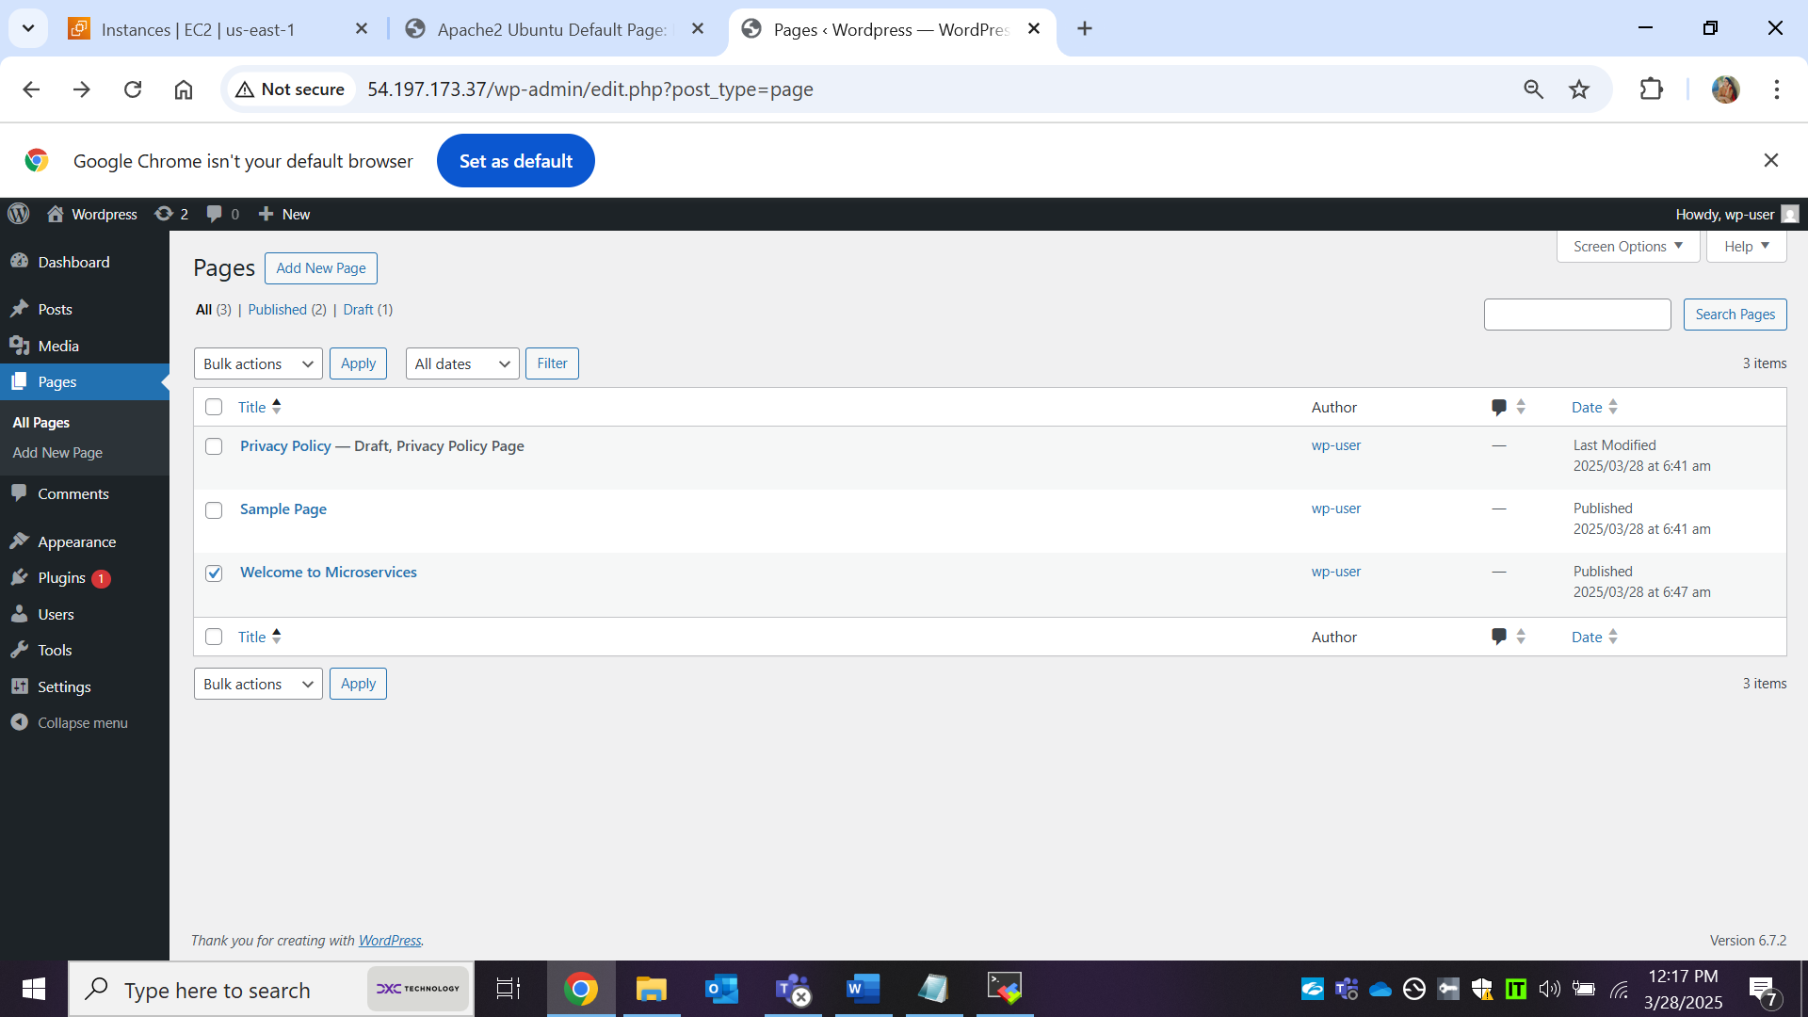

Copy your pulish URL & paste in new webserver page and check your pushlished content accessing or not:

<http://54.197.173.37/index.php/welcome-to-microservices/>

